**DOCKER INSTALL**

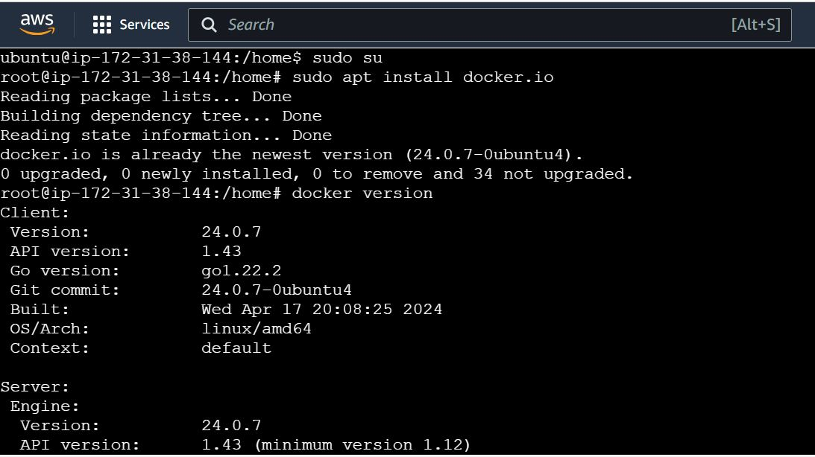

**CREATING DOCKER-FILE**

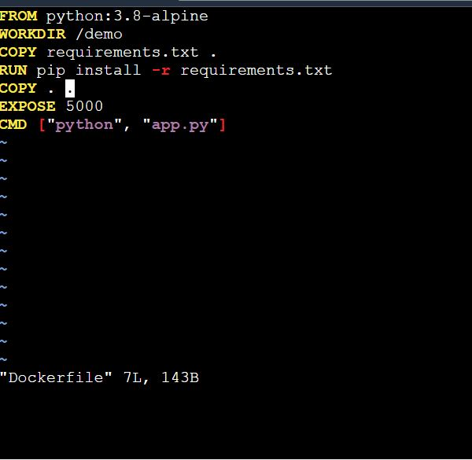

**CREATING DOCKER IMAGE – BUILDING**

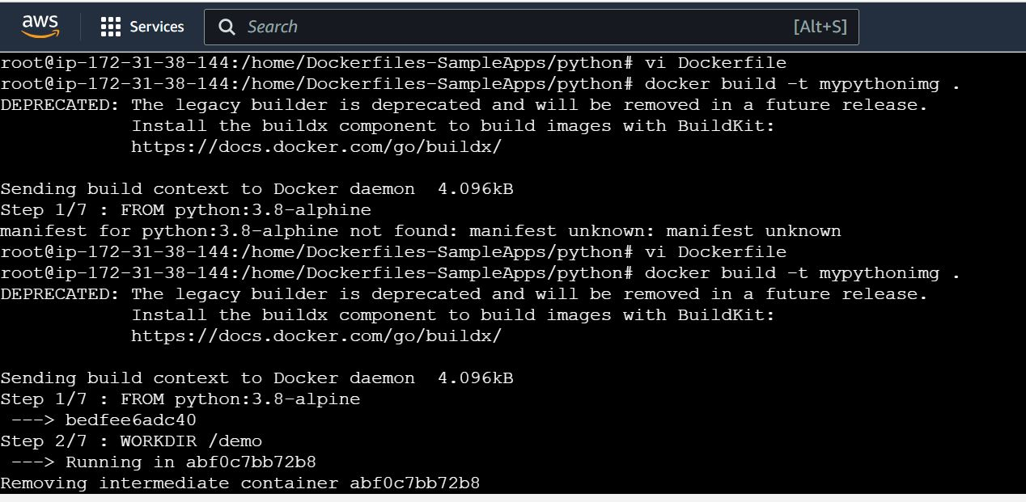

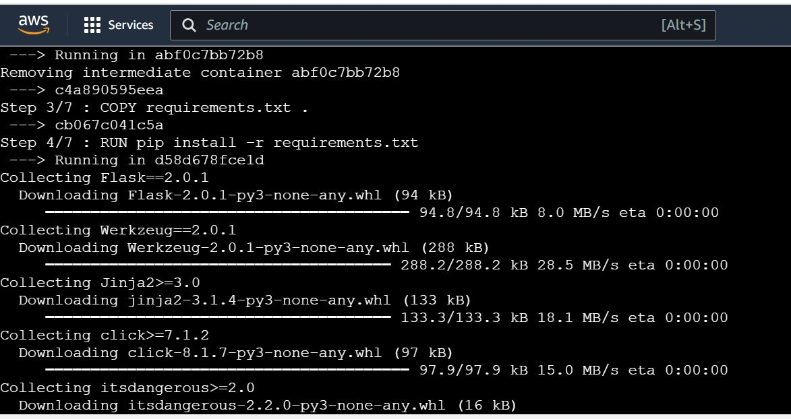

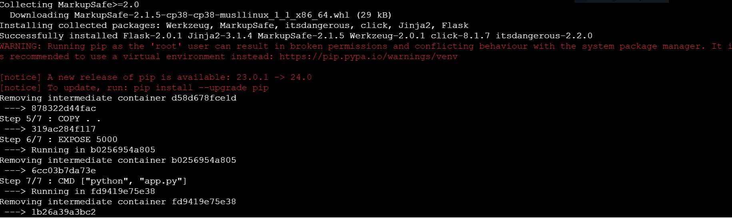

**CONTAINERISING THE DOCKER IMAGE – NEW CONTAINER**

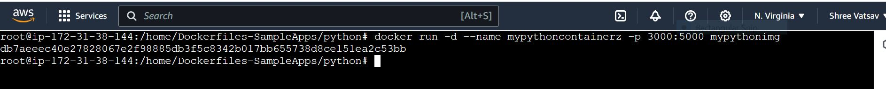

**VOLUME BASIC COMMANDS**

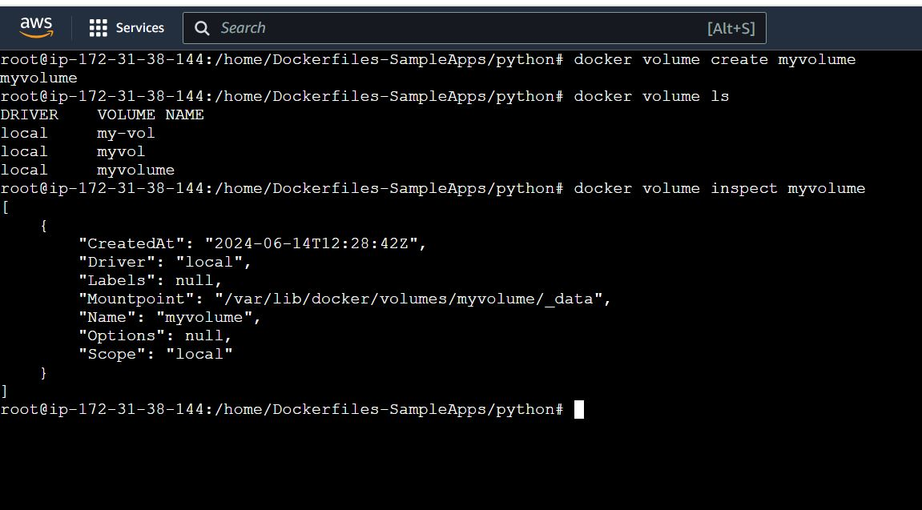

**NETWORK BASIC COMMANDS**

